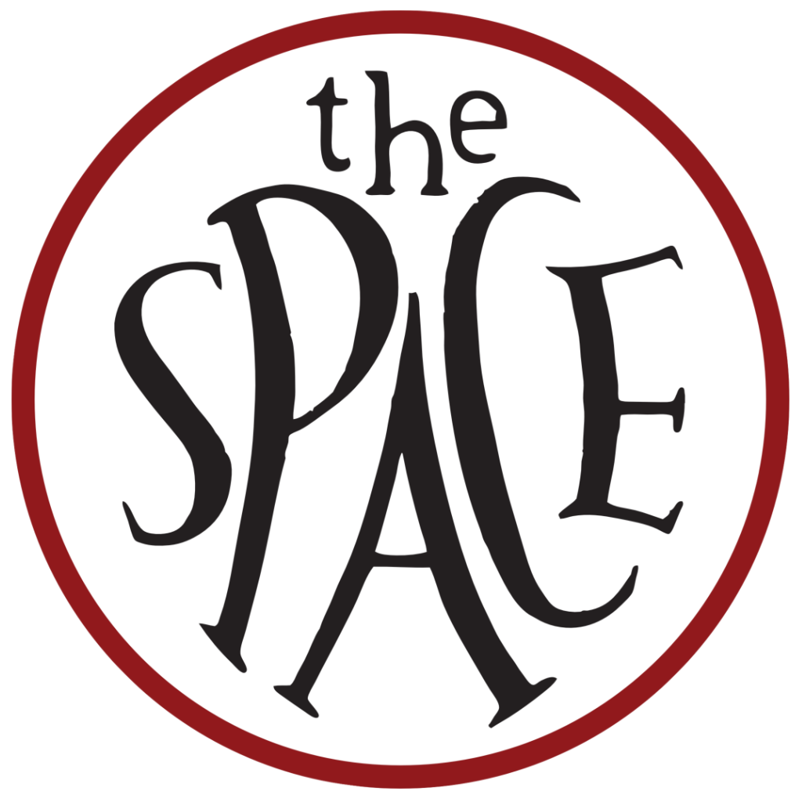
The Space
Proposal Form

Contact Details

Name of company/artist
Name of lead contact
Preferred pronouns
Email
Telephone
Where are you based?

Online presence

Website
Facebook
Twitter
Instagram
YouTube
Other social media links

Proposal Information

Title of piece
Writer (if applicable)
Director (if applicable)
Other creative team
Approximate running time

Has the show been performed before? YES/NO (If yes, please tell us in what capacity and where, e.g. a full run, online, a scratch, work-in-progress, in or out of London)
What run length would you consider? (Please tick all that apply).
◻One week ◻Two weeks ◻Three weeks

Are you interested in having your show live-streamed? YES/NO

Are there any dates within the given period which you’re unavailable for? If so, please give us details.

Are you applying as part of a larger tour? If so, please give us details.

About the Company

Please tell us a bit about you: who you are, what you’ve done so far, and what kind of work you make. If you’re a new company, tell us about you as individuals, what’s brought you together and what kind of projects you’re hoping to create. (Max 300 words)
About the Production

Tell us about the production you’d like to bring to the Space. We’d like to hear about the plot, characters and themes, but also about what makes it distinctive or exciting to you. Why this show? Why now? (Max 500 words)

About your Audience

Who is your target audience for this show? How do you plan to reach them? Give us as much detail as possible about your marketing strategy for the production. This is also an opportunity to tell us about any particular interest groups you’d like to target, or audience outreach activities you’d like to run as part of the project. (Max 500 words)
Reviews/feedback for previous work.

If you are a new company, this can include individual projects.

Opportunities

How did you hear about this opportunity?

I DO/DO NOT* wish to receive e-mails from the Space regarding
future opportunities. *Delete as necessary

Please submit the following (where relevant/available):

* CVs of any of the creative team currently confirmed (writer, director, producer, actors, designers)

* Script - If you are submitting a new play, please submit the script

* Video - We appreciate that some pieces work better off the page so we wanted to give you an option of submitting a max 3 min video. Sell us the piece, either by telling us why we should programme it, reading an extract or giving examples of your past work. Please provide a YouTube or Vimeo link rather than sending it as an attachment.

* Equal Opportunities & Monitoring form - This form is optional and has no influence on your application. However it will help us monitor the diversity of people who are drawn to the Space and ensure our arts programme is kept accessible to all.

Please send this form as a .pdf or .doc only to Adam Hemming, at adam@space.org.uk

